|  |  |  |  |
| --- | --- | --- | --- |
|  | **Course Name: Design Patterns/Thinking LAB** | **EXPERIMENT NO. 13** | |
| **Course Code: 20CP210P**  **Faculty: Dr. Ketan Sabale** | **Branch: CSE** | **Semester: IV** |
| **(To be filled by Student)**  **Submitted by: Jangle Parth**  **Roll no: 22BCP083** | | | |

Objective: To familiarize students with standard Behavioral design patterns.

Experiment: Explain the Memento design pattern and write a program using any object-oriented programming language to demonstrate the working of Memento design pattern.

Theory: Memento design helps in saving each and every state of a particular object . example of memento design pattern is GitHub it is used to save changes in your code. It takes help of caretaker to keep track on memento object.

**Problem Statement Explanation:**

In making of a tank there are many states like material purchased ,shell cutting done, then cone cutting done etc. to save this state we will use memento design patten it has a caretaker class labor which is responsible for changing the state of object i.e. tank and SAP class which saves all the state changes in the code.

**Flowchart Explanation:**

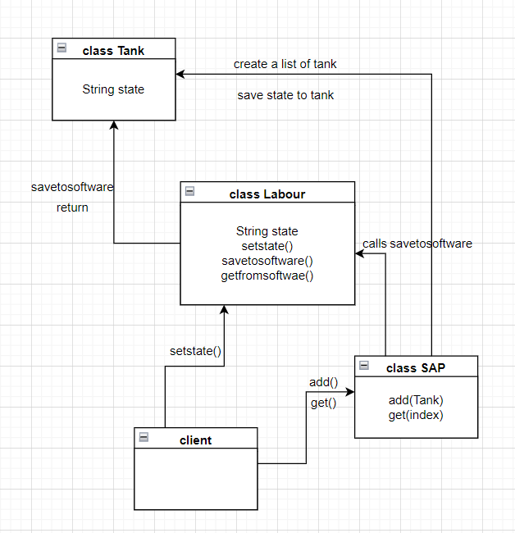

**Code:**

package momento;

import java.util.ArrayList;

class Tank {

    String state;

    public Tank(String state) {

        this.state = state;

    }

}

class Labour {

    String state;

    public void setstate(String state) {

        this.state = state;

    }

    public Tank savetoSoftware() {

        return new Tank(state);

    }

    public void getFromSoftware(Tank tank) {

        state = tank.state;

    }

}

class SAP {

    ArrayList<Tank> tankstates = new ArrayList<Tank>();

    public void add(Tank state) {

        tankstates.add(state);

    }

    public Tank get(int index) {

        return tankstates.get(index);

    }

}

public class momento {

    public static void main(String[] args) {

        Labour l = new Labour();

        SAP B1 = new SAP();

        l.setstate("Cutting Done");

        B1.add(l.savetoSoftware());

        l.setstate("Manhole Assembly Done");

        B1.add(l.savetoSoftware());

        System.out.println("Current State: " + l.state);

        l.getFromSoftware(B1.get(0));

        System.out.println("Stating State: " + l.state);

        l.setstate("Airvent Assembly Done");

        B1.add(l.savetoSoftware());

        l.setstate("Shell Assembly Done");

        B1.add(l.savetoSoftware());

        l.setstate("Mounted Manhole and Airvent on Tank");

        B1.add(l.savetoSoftware());

        System.out.println("Whole Progress: ");

        for (int i = 0; i <= B1.tankstates.size() - 1; i++) {

            System.out.println(B1.tankstates.get(i).state);

        }

    }

}

**Output:**

